I will explain the mapping logic behind these two beatmaps that have been suspected:
Sick Enough to Die (feat. Mellow)
- 00:02:010 –> 01:04:469 –
For this section, the base spacing is set as follows: for 1/2 spacing and above, I use 1.3x. For 1/4 spacing, I use 0.6x (streams) and 1.0x (kick sliders and slider-to-note spacing) to avoid streams becoming excessively wide. This is also consistent with the general logic I use in most of my maps（eg https://osu.ppy.sh/beatmapsets/2098738#osu/4745907 https://osu.ppy.sh/beatmapsets/2260829#osu/4813488 etc）
Except for certain patterns where I used different, reasonable values either to maintain the visual appeal of blankets（eg 00:20:206 (3,4) – etc.）or to emphasize accents / higher notes（eg 00:28:075 (2,3,4) - 00:29:059 (4,5,1,2) – 01:00:780 (6,1) - 00:40:370 (5,6,7) - etc.）
There are many traces here that clearly reflect my own mapping style. For example, 00:55:985 (4,5) was mistakenly set to 1/2 spacing (a very typical mistake that can happen when using two fixed spacing values). Also, in 00:20:698 (4,1,2,3,4), when placing 00:21:682 (1), I referenced 00:20:698 (4) and created an axis-symmetric slider based on it; then 00:22:911 (2,3,4) was placed based on the midpoint of 00:21:682 (1).
00:03:731 (4,6) — For aesthetics, I placed the sliderend of 00:04:714 (6) on the perpendicular bisector of 00:03:731 (4). This idea appears not only in this map, but also in many of my other maps.
00:06:682 (2,4) - 00:34:469 (4,5) – Exactly the same slider, rotated around the centre.

00:20:698 (4) from 00:20:206 (3,4) was produced by doing Ctrl+G -> Ctrl+H on 00:20:206 (3).

00:24:632 (4,5) – The same slider flipped vertically.

00:53:157 (1,2) – The same slider flipped horizontally.

01:01:026 (1,8,10) – The same slider, made via Ctrl+G and then flipped horizontally.

- 01:04:960 –> 01:20:698 -

The vocal pitch becomes noticeably higher here, so I set 1/2 spacing to 1.5x ds.

There are still many places that show my own mapping habits. For instance, at 01:15:288 (3,4), I used an irregular slider to create a small blanket (this matches my personal habits like https://osu.ppy.sh/beatmapsets/2431107#osu/5295874 01:02:043 (1,2) -01:06:361 (2,1) -，https://osu.ppy.sh/beatmapsets/2462940#osu/5389347 00:23:438 (1,5) - 00:34:517 (1,1) - etc. There are too many to list one by one）

01:07:173 (2,3,4) – A very common mapping pattern in my maps: three objects forming a (slightly curved) short straight-line pattern. You can see it in this map at 03:37:419 (4,5,6), and also inand https://osu.ppy.sh/beatmapsets/2487672#osu/5462643 01:30:537 (1,2,3) - https://osu.ppy.sh/beatmapsets/2232437#osu/4739649 01:46:600 (1,2,3) – etc. ）

01:18:731 (1,2,3,4,1,2,3,4) - 03:18:731 (1,2,3,4,1) - 03:42:337 (1,2,3,4,5) – This is also a square composite pattern I use extremely often. I’ve been using it since square jumps were “buffed” in 2019. Early examples include https://osu.ppy.sh/beatmapsets/2071865#osu/4335617 01:31:259 (1,2,3,4,1) - https://osu.ppy.sh/beatmapsets/899538#osu/2164598 01:11:587 (1,2,3,4,1) - etc. Later it evolved into more spacing-reasonable shapes, such as https://osu.ppy.sh/beatmapsets/2487672#osu/5462643 01:19:287 (1,2,3,4,1,2) - https://osu.ppy.sh/beatmapsets/2436971#osu/5313610 00:31:317 (1,2,3,4,5,6,7,8,1,2) -

- 01:20:698 –>01:36:436 –

This is a short chorus. I felt that the intensity of 1/4 stacks might not be strong enough, so to highlight the chorus I set 1/4 stream spacing to 0.8x.

The large number of 1/1 S-shaped sliders that start appearing here further proves this map is human-made (mainly because the earlier part did not have enough 1/1 rhythms)：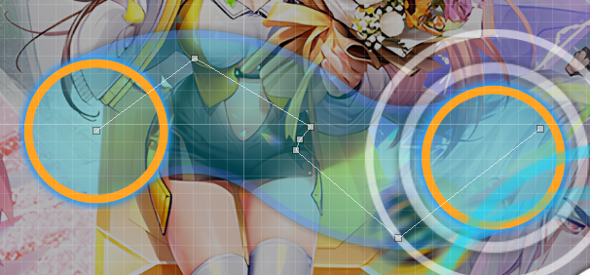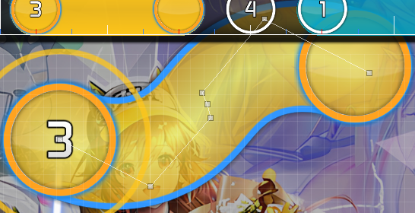etc.，Also, all of these 1/1 S-shaped sliders were created using a “three-middle-point” method, which matches my recent habits for making S-shaped sliders (eg. https://osu.ppy.sh/beatmapsets/2405262#osu/5228046 02:48:832 (1,1) - 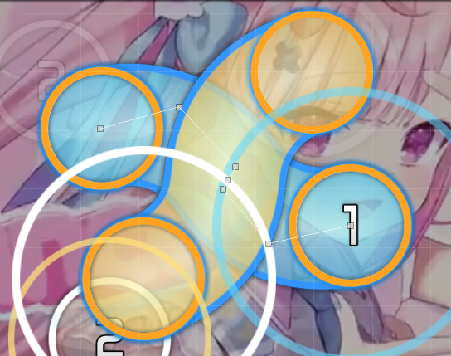，https://osu.ppy.sh/beatmapsets/2467014#osu/5401559 01:11:248 (3) -
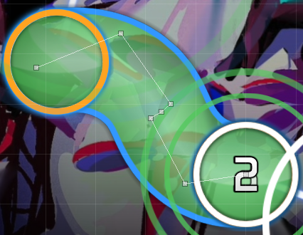，https://osu.ppy.sh/beatmapsets/2462940#osu/5389347 00:23:438 (1) -00:19:604 (6) - 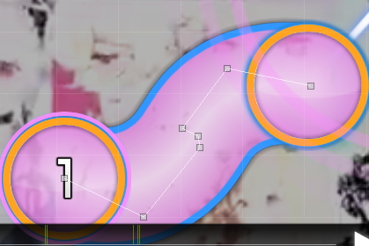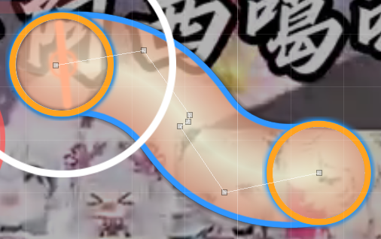etc.）
For 01:20:698 (1,5), the placement of 01:22:419 (5) is based on the midpoint of 01:20:698 (1).

01:23:157 (6,7) – I used larger spacing here because the violin is very prominent and needs emphasis, and also to avoid 01:22:419 (5,9) - looking too close and visually unpleasant.
01:27:829 (4,5) – Larger spacing because the vocal pitch rises significantly here.
01:29:059 (2,3) -> 01:30:042 (4,5) -> 01:31:026 (6,7) – The change also follows the vocal pitch (2.0x -> 1.9x -> 1.5x).
01:35:206 (3,4) - vs. 01:35:698 (6,7) - – Spacing is increased to emphasise the drumbeats.

01:36:436 –>01:52:173 –
This is a relatively calm “rest” section, so the spacing is adjusted back to match the first part: 1/2 spacing at 1.3x and 1/4 spacing at 1.0x.

01:51:313 – I intentionally left a 1/2 gap and did not follow the vocal, in order to contrast with the immediately following vocal streams: 01:52:419 (2,3,4,5,6,7,8) - 01:56:354 (2,3,4,5,6,7,8) - . This prevents the rest section from becoming too intense and reducing how much those streams stand out.
(I only use this kind of run at the same vocal part: 03:46:518 (2,3,4,5,6,7,8) - 03:56:108 (1,2,3,4,5,6,7,8,9) - to preserve its “highlight” effect.)

01:52:173 – ->02:07:911 -
I consider this the point where the male vocal’s passion starts to show and needs emphasis, so I increased SV to 1.2x. Since the vocal pitch here is not as high as in the 01:04:960 segment, and because I want to leave adjustment room for DS later, I kept 1/2 spacing at 1.3x.

01:52:665 (4,5,6,7,8) – vs. 01:53:649 (10) - I intentionally arranged a “fake blanket” (or parallel) here. I really like this pattern so I also applied the same idea at 02:13:567 (1,4) - , showing consistency in my mapping logic. 03:17:747 (4,5) - 03:25:616 (4,5) - are two variations and extensions of the same idea. 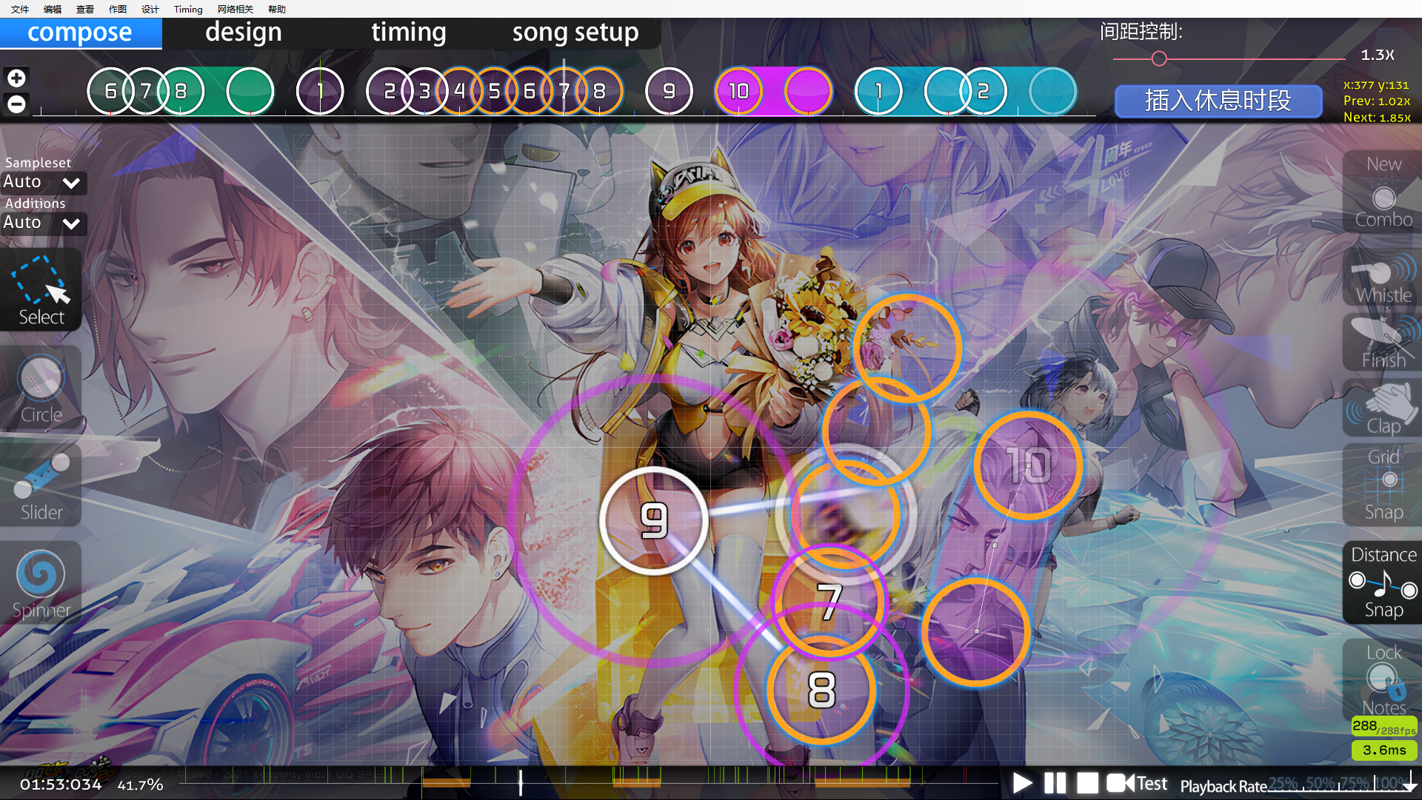

01:52:419 (2,3,4,5,6,7,8) - 01:56:354 (2,3,4,5,6,7) – I used 1.0x spacing streams here to create emphasis. I also considered changing the stream direction between 01:52:665 (4) and 01:56:600 (4) because the vocal and hi-hat are relatively stronger here, and the stream starts off-beat. Turning the stream direction on the beat also helps cue players. The same idea is applied in the same vocal part at 03:46:518 (2,3,4,5,6,7,8) - 03:56:108 (1,2,3,4,5,6,7,8,9).

02:07:419 (3,4,5,6,1) - Since this is not vocal but a weaker drum part the spacing is reduced to 0.8x.

- 02:07:911 –> 02:23:649 -
Because the song’s rhythmic intensity rises significantly and introduces many jump patterns, spacing is no longer strictly fixed. 1/4 spacing is still kept at 1.0x. This also matches how a person would logically analyse the song while mapping.
02:14:550 (4,1,2,3) -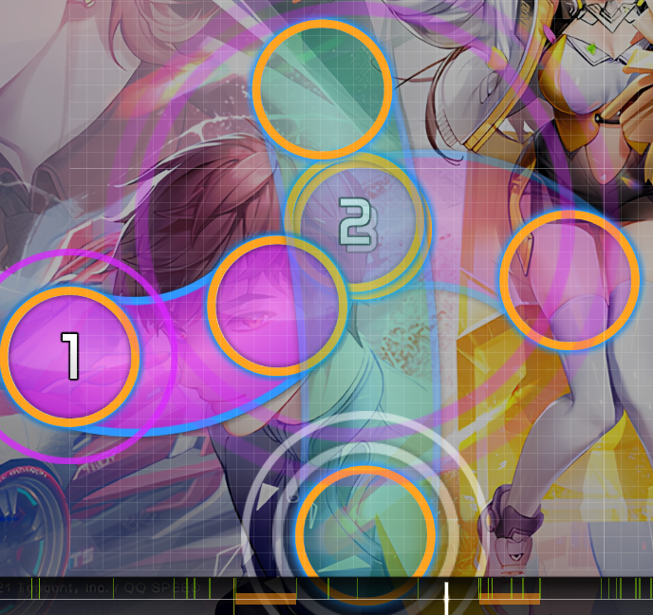 AI would not be able to place such an exquisite pattern. 02:14:550 (4,1) - is placed by aiming 02:15:288 (1) at the midpoint of 02:14:550 (4) (and I will point out later that this pattern is used a lot in this map), while 02:15:657 (2) -is completely overlapped by the body of 02:14:550 (4) -.

02:16:518 (5,4) -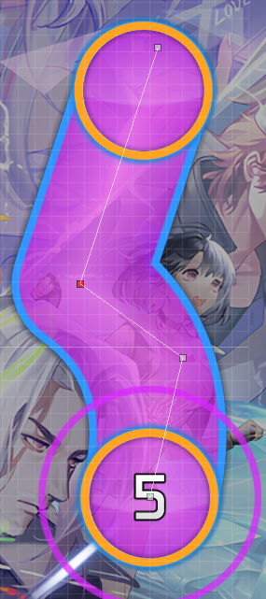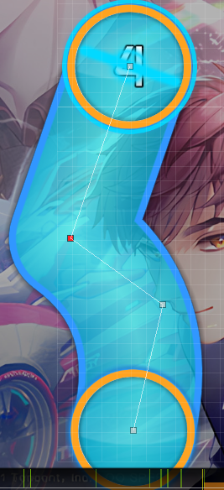 this is a Ctrl+G reuse of the same slider.

02:21:928 (2,3,4,5,6,7) – A very nice parallelogram, and the slight human-level placement imperfection helps prove it was manually placed.

- 02:23:649 –> 02:39:387 –
Chorus section, since SV at 1.2x is already fast enough, I did not adjust it here. Instead, I used more jump patterns with non-standard DS to represent intensity.

02:23:157 (8,1) - One example of my attention to detail: 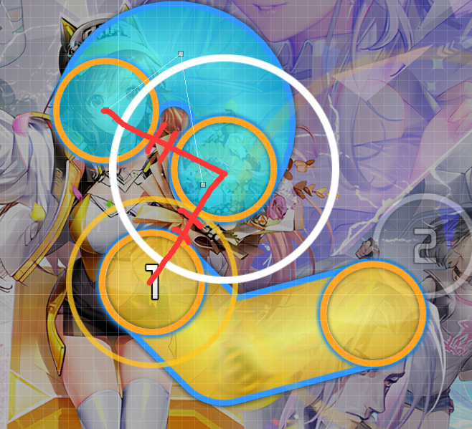 to show the transition into the chorus, I set 1/4 spacing larger, and it forms an isosceles triangle with the head and tail of 02:23:157 (8).

02:25:124 (4,5,1,2) - An isosceles triangle that fits the flow, plus its altitude line.

02:35:452 (1,2,3,4,5,1) - A pattern made of many symmetries and regular shapes. 02:35:452 (1,2,3) - forms an equilateral triangle，02:35:944 (3,4) - takes the perpendicular line of 02:35:452 (1,2) – and 02:35:698 (2) – goes thry the midpoint of 02:36:190 (4) - . (02:36:190 (4,1) – follows the same logic.) 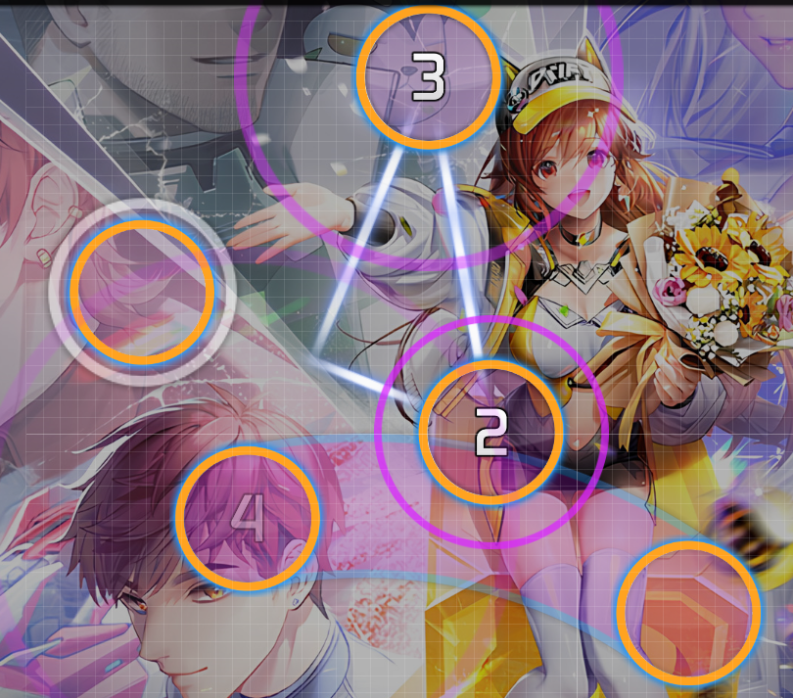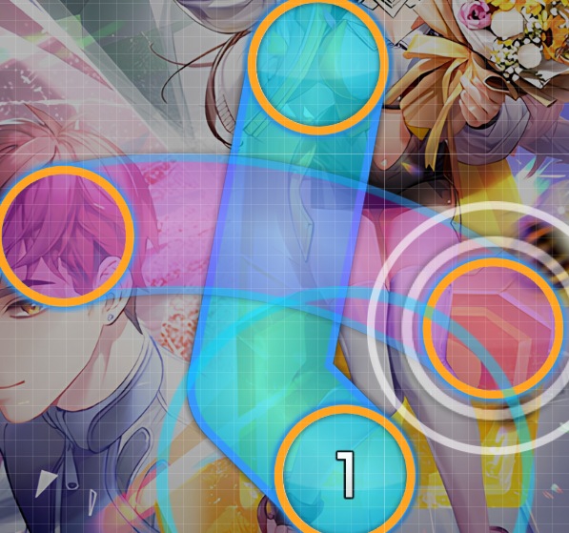
02:37:911 (2,3,4,5,6,1) - A small axis-symmetric pattern made from an isosceles trapezoid and an isosceles triangle. 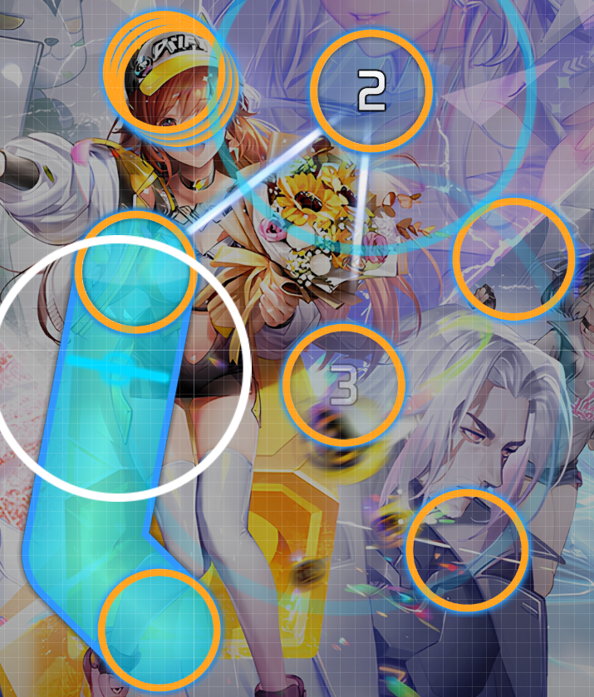

02:39:387 (1) - This should be very easy to recognise: it reuses the “wing shape slider” from https://osu.ppy.sh/beatmapsets/368060#osu/807074 with minor edits and rotation for aesthetics). It also matches the “wing” logo from QQ Speed (the game this song comes from) and the Chinese character “飞” (“fly”). 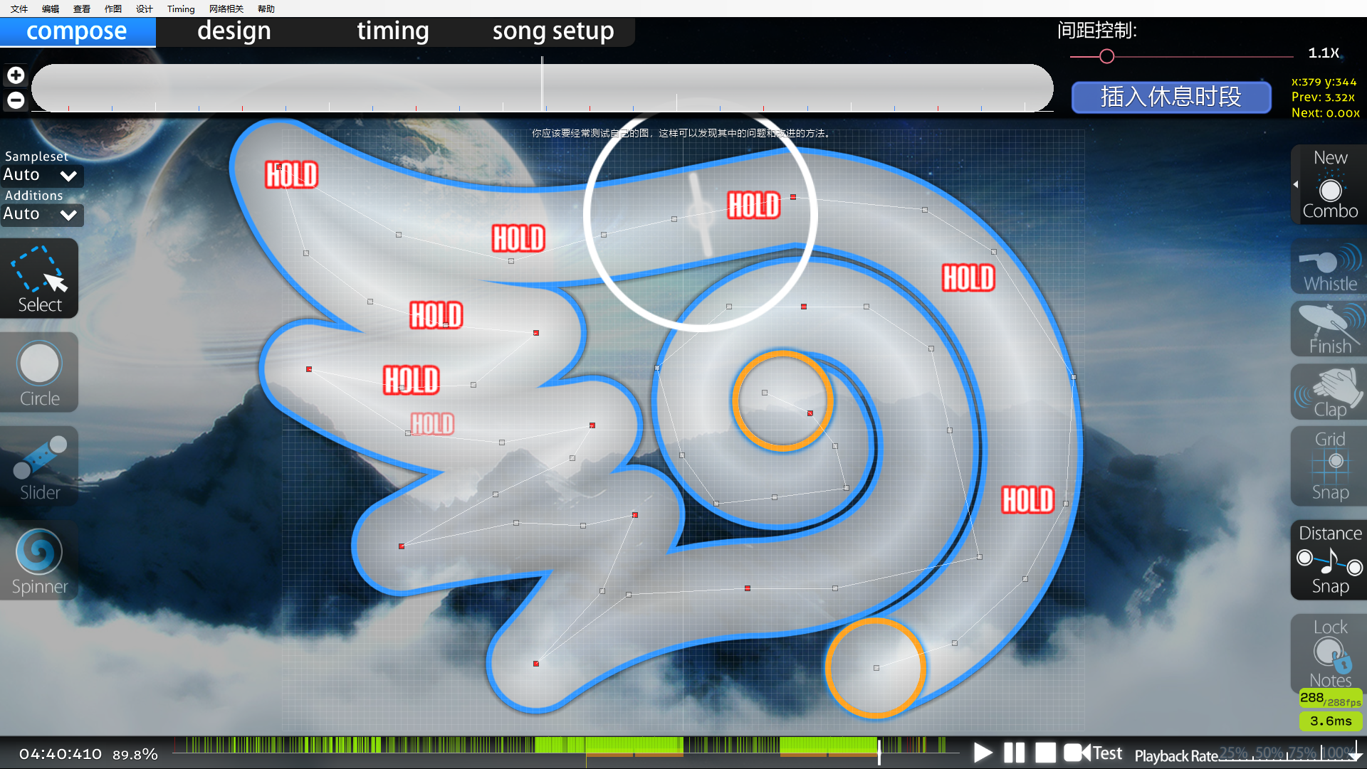

- 02:59:059 – ->03:14:796 –

Entering one of the song’s climax sections, the spacing becomes noticeably larger, but the base spacing remains 1.5x (e.g., 02:59:059 (1,2,3,4) - 03:02:501 (1,2) - 03:06:928 (1,2) - etc.).

03:01:272 (2,4) - 03:10:370 (4,3) - Clearly a manually arranged blanket.

03:03:731 (6,7) -03:04:714 (1,2) - obvious symmetry

03:10:862 (1,2,3) - A set of equilateral triangles.

03:05:945 (5,6) - Since it’s only drum hits here and the timbre is similar, I used two 1/2 sliders to cover it.

03:08:895 (1,2,3) - Similar logic to 02:14:550 (4,1,2,3) - , three objects form an isosceles triangle, and 03:09:632 (3) - is placed so that it fully overlaps the sliderhead of 03:08:895 (1) -sliderhead fully overlap and passes through the midpoint of the straight segment.

03:12:091 (1,3,2,3) - One of my most frequently used mapping techniques “stack reuse”.

- 03:14:796 –
To build emotion going into the next chorus, I used a lower SV of 1.1x here, while the base spacing is still 1.5x.

03:16:272 (5,2) - 03:19:714 (1,3) - Stack reuse.

03:25:616 (4,5) - When mapping, 03:26:108 (5) - is a 180° rotation plus scaling version of 03:25:616 (4) - .

- 03:30:534 –>03:46:272 –

A chorus section. SV returns to 1.2x, and base spacing remains 1.5x.

03:36:436 (1,2,3,4,5) - While mapping, I felt a star-shaped pattern fit this part well, but since it was placed by hand it’s not perfectly regular.
03:39:387 (4,1) - obvious symmetry

03:45:042 (3,4,5,6,7,8,9) - The smaller spacing here is meant to set up the burst at 03:46:272 (1,2,3,4,5,6,7,8) - . Since the vocal intensity is weaker here, I used an even smaller 0.6x spacing.

- 03:46:272 - -> 04:02:010 –
The final chorus is also the biggest climax of the song, so SV is set to 1.3x.

03:54:141 (1,4,5) - A sequence of Ctrl+G kick sliders.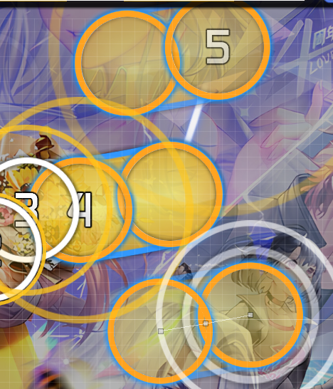

04:01:026 (1,2,3,4,5) - The last stream of the song, so I used the same 1.0x stream spacing as the hardest part of the map.

- 04:05:944 –->end
Nothing much to say here: it’s simply note arrangement on a square, following the melodic direction.

Summary:
One of the core logics of this map is “midpoint placement” and “regular geometric shapes.” Thanks to my mapping habits, the map contains many different regular shapes: abstract ones such as centrally symmetric patterns, and concrete ones such as equilateral triangles and squares. The rhythm interpretation is also fully self-consistent from beginning to end. More importantly, when mapping, my overall slider direction and flow direction follow changes in the song’s pitch. All of these strongly demonstrate that this map was entirely made by me.

If you still have doubts, feel free to point them out.

Appendix:
In this map:

Stack reuse patterns: 03:12:091 (1,2) - 03:12:583 (3,3) - 03:25:370 (3,1,4,3) -03:41:108 (3,5) -
Vertical/horizontal axis-symmetric patterns or reused sliders: Various 1/1 z-shape, s-shape, ω-shape sliders;，00:20:206 (3,4) -00:24:632 (4,5) -00:28:075 (2,3) -00:37:911 (3,4) -00:51:682 (3,4) -00:53:157 (1,2) -01:17:501 (4,6) - 02:09:878 (1,2,3,4) -02:15:288 (1,3) - 03:03:731 (6,1) - 02:25:124 (4,5,1,2) - 03:39:387 (4,1) -03:48:731 (3,4) - 03:51:190 (5,6) -
Centre-rotation patterns or reused sliders: 00:06:682 (2,4) - 00:14:550 (2,4) - 00:34:469 (4,5) - 00:50:206 (5,7) – (旋转60°) 01:02:501 (8,10) - 01:48:239 (1,3,5) - 01:54:141 (1,2) - 02:30:288 (3,4) -03:05:945 (5,6) -03:21:436 (3,4) - 03:54:141 (1,4,5) -
Blankets: 00:03:731 (4,6) - 01:15:288 (3,4) - 01:32:747 (2,4) - 01:37:419 (3,1) -03:28:321 (3,6) -

